**NEHEMIAH UNIVERSITY STUDENTS & GRADUATES UNION**

**Excellence Team**

**MATHEMATICS**

**CALCULUS**

**Worksheet**

1. Evaluate these series
2. 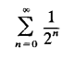
3. 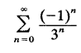
4. Find the sum of the series 
5. Find the equation of every tangent line to the curve y = $e^{x}$ containing the point (−1, 0). This is not a point on the curve.
6. For the function f(x) = $e^{\frac{-x}{2}}$, compute the first, second and third derivatives of f(x).
7. The point (0, 4) is not on the graph of y = x + 1/x, but it is contained in exactly one tangent line to the graph.
8. Find the one value of a for which the tangent line to the graph of y = x + 1/x at (a, a + 1/a) contains (0, 4).
9. Write the equation of the corresponding tangent line.
10. Find the limits
11. 
12. 
13. 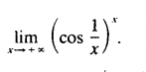
14. If the function 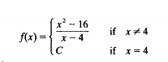is continuous, what is the value of C?
15. In an automobile crash­test, a car is accelerated from rest at 2 m/s2 for 5 seconds and then decelerated at −4m/s2 until it strikes a barrier. The position function is, 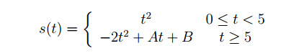
16. Assuming that both s(t) and s’(t) are continuous at t = 5, determine **A** and **B.**
17. The barrier is located at s = 33 meters. Determine the **velocity** of the car when it strikes the barrier.
18. For each of the following functions, compute the derivative.
19. y = $\frac{e^{x}-e^{-x}}{e^{x}+e^{-x}}$
20. y = x ln(x) – x

**Applications of differentiation.**

1. A particle moves along the positive x­axis with velocity 5 units/second. How fast is the particle moving away from the point (0,3) (which is on the y­axis) when the particle is 7 units away from (0,3)?
2. The top of a 25-foot ladder, leaning against a vertical wall is slipping down the wall at the rate of 1 foot per second. How fast is the bottom of the ladder slipping along the ground when the bottom of the ladder is 7 feet away from the base of the wall? 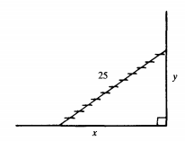

**Keep on believing!**